Item | File Name | Object | Location | Time | Owner
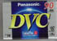 | archive_1.jpg | DV-tape | Sound Room | 22:33 | Ron
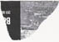 | archive_2.jpg | torn paper | Corridor I | 20:00
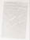 | archive_3.jpg | breath | Surround Sound Room | 21:35 | Steve
 | archive_4.jpg | key holderkeydd | Sound Room | 22:24
 | archive_5.jpg | coke |  | 21:52
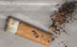 | archive_6.jpg | cigarette butt and ash | Corridor II | 9:46 | Simone
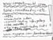 | archive_7.jpg | flyer | main staircase | 22:39
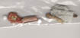 | archive_8.jpg | objects | Corridor I | 20:44
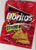 | archive_9.jpg | Doritos bag | Sound Room | 22:20
 | archive_10.jpg | gum | Douglas | 21:04
 | archive_11.jpg | receipt | Corridor I | 20:26 | Tim
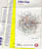 | archive_12.jpg | London Tube Map | Surround Sound Room | 21:51
 | archive_13.jpg | saliva | Surround Sound Room | 21:45
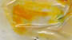 | archive_14.jpg | lemon & coke | Surround Sound Room | 21:31
 | archive_15.jpg | paper bits & hair | Surround Sound Room | 21:39
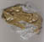 | archive_16.jpg | bubblewrap & tape | Surround Sound Room | 22:30
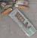 | archive_17.jpg | content of an ashtray | Corridor II | 20:50
 | archive_18.jpg | 3D-glasses | Sound Room | 22:23
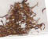 | archive_19.jpg | tobacco | Green Room |  | Nico
 | archive_20.jpg | hair | Corridor II | 21:50
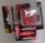 | archive_21.jpg | batteries & package | Sound Room | 22:24
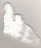 | archive_22.jpg | tissue | Surround Sound Room | 21:25
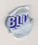 | archive_23.jpg | blue tag |  |  | Joel
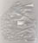 | archive_24.jpg | plastic bag | staircase II | 20:50
 | archive_25.jpg | beer sample (Carling), | Corridor I (Glove Collection) | 19:51 | Simone Strifele
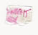 | archive_26.jpg | bit of paper
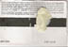 | archive_27.jpg | train ticket & chewing gum | Surround Sound Room | 21:33
 | archive_28.jpg | Ash & cake | Green Room |  | Nico
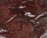 | archive_29.jpg | cake | Green Room | 21:01
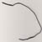 | archive_30.jpg | wire with plastic coat | staircase I | 20:51
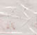 | archive_31.jpg | unknown liquid | Surround Sound Room | 21:43
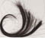 | archive_32.jpg | hair | Sound Room | 22:38
 | archive_33.jpg | receipt | staircase II | 22:13
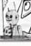 | archive_34.jpg | program Wormhole Saloon III | staircase II | 22:13
 | archive_35.jpg | Taxi company business card | staircase II | 22:13
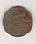 | archive_36.jpg | one pence coin | staircase II | 22:13
 | archive_37.jpg | lighter | staircase II | 22:13
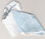 | archive_38.jpg | bit of an envelop | staircase II | 22:13
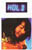 | archive_39.jpg | flyer | staircase II | 22:15 (not sure)
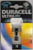 | archive_40.jpg | battery package | Sound Room | 22:40 | Charlie
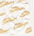 | archive_41.jpg | Halls sweets wrap | Sound Room | 22:30
 | archive_42.jpg | receipt
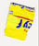 | archive_43.jpg | sweets package | Surround Sound Room | 21:22
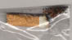 | archive_44.jpg | cigarette buds | staircase II | 20:50
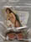 | archive_45.jpg | chocolate & naked girl |  |  | James de Carteret
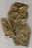 | archive_46.jpg | tape | Sound Room | 22:32
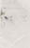 | archive_47.jpg | Carling | Corridor I | 20:10
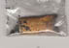 | archive_48.jpg | cigarette bud & ash | Surround Sound Room | 20:17
 | archive_49.jpg | pen |  |  | Letitia Calin
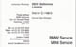 | archive_50.jpg | business card | Surround Sound Room | 20:21 | Claire
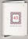 | archive_51.jpg | empty box of matches | Sound Room | 22:31
 | archive_52.jpg | sweets wrap (Chewits), |  | 21:34
 | archive_53.jpg | red wine | staircase II | 20:17
 | archive_54.jpg | aluminium foil & plastic wrap |  | 21:30
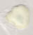 | archive_55.jpg | chewing gum and saliva |  | 20:44 | John
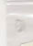 | archive_56.jpg | bit of paper |  | 21:39
 | archive_57.jpg | bottle of cider with cigarette buds and ash | Surround Sound Room | 21:42
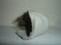 | archive_58.jpg | bit of egg box | Sound Room | 22:25
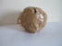 | archive_59.jpg | newspaper & tape | Sound Room | 22:24
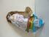 | archive_60.jpg | egg box, gum & tape | Sound Room | 22:25
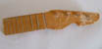 | archive_61.jpg | guitar grip | Sound Room | 22:26
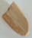 | archive_62.jpg | wood | Sound Room | 22:26
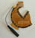 | archive_63.jpg | cable & bit of guitar | Sound Room | 22:30
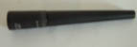 | archive_64.jpg | eye-liner | Surround Sound Room | 22:40 | Paloma, Gromely, Boris
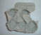 | archive_65.jpg | egg box | Sound Room | 22:19

